Temperature module description

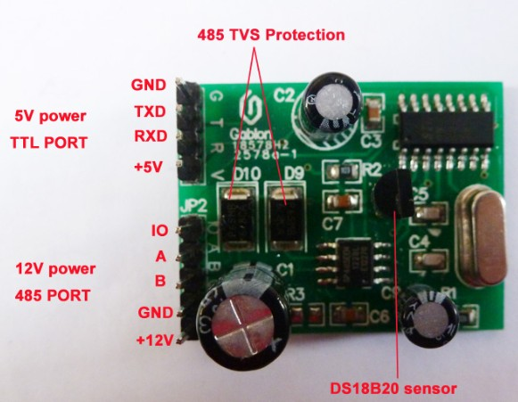

Serial port settings：9600，N，8，1

USB to RS485 Connection ModbusRTU
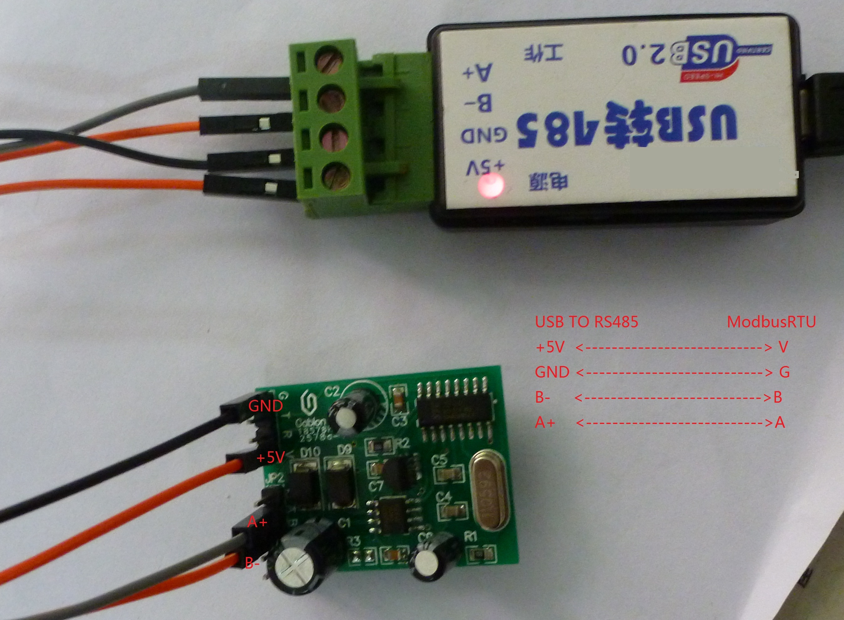

Connection(See above picture)：
USB TO RS485 ModbusRTU
+5V Connected together V
GND Connected together G
B- Connected together B
A+ Connected together A

User's Manual

Use of video

